Find the Nyquist Plot for the following bode plot. The open loop has one poles in RHP, is the closed loop stable?
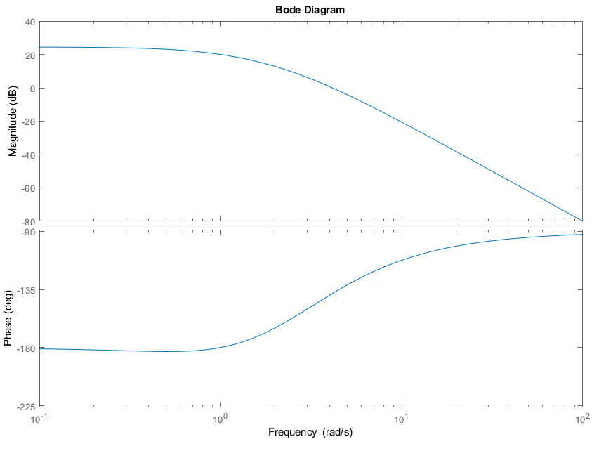
Freq (rad/s) | Mag (dB) | Mag | Phase= θ | X=Mag*cos(θ) | Y= Mag*sin(θ)
0.01 | 25.4 |  | -180
0.1 | 25 |  | -181
0.3 | 24 |  | -182
0.5 | 23 |  | -183
0.8 | 21 |  | -182
1 | 20 |  | -180
1.3 | 18 |  | -176
2
4
10

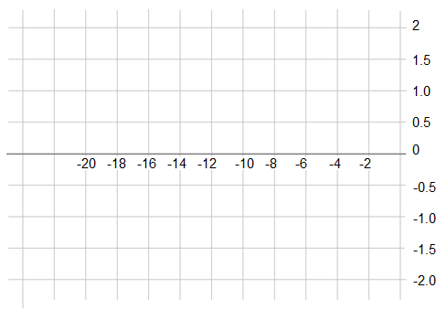

Find the Nyquist Plot for the following bode plot. The open loop is stable, is the closed loop stable?
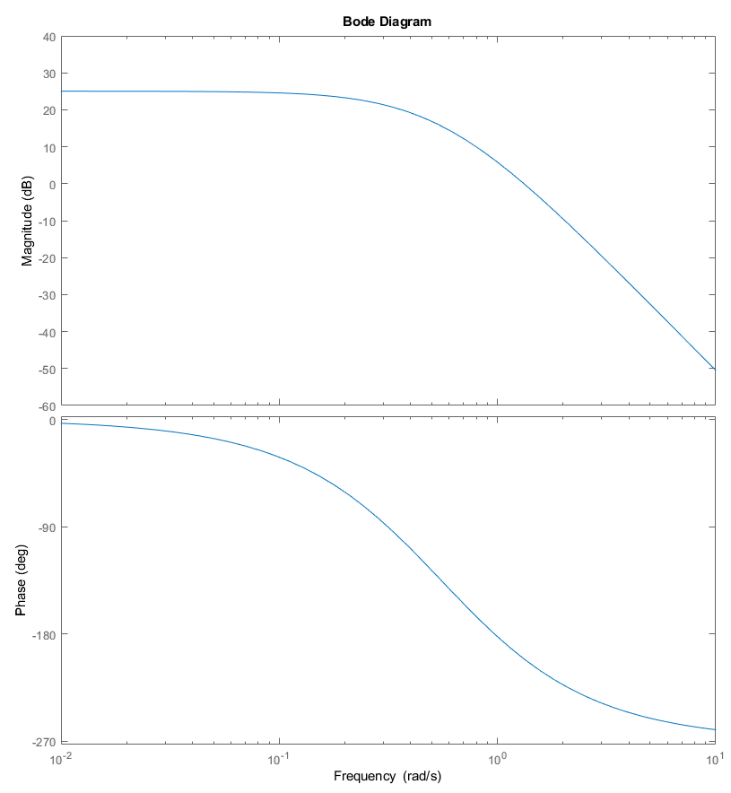
Freq (rad/s) | Mag (dB) | Mag | Phase | X = Re{s} | Y = Im{s}
0.01
0.1
0.3
0.7
1 |  |  | -182
1.26
5

